**Assignment 1: Linear Regression from Scratch**

Problem Statement

You are given a dataset containing the number of study hours of different students and their corresponding scores in a particular exam. The task is to develop a linear regression model from scratch that predicts the exam score based on the number of study hours.

Approach

* **Step 1:** Generate the dataset. Plot the data points to visualize the relationship between study hours and exam scores.
* **Step 2:** Formulate the linear regression equation: **y = mx + c**, where **y** is the exam score, **x** is the number of study hours, **m** is the slope, and **c** is the y-intercept.
* **Step 3:** Calculate the cost function (mean squared error) to measure the accuracy of your model.
* **Step 4:** Implement gradient descent to minimize the cost function. Update **m** and **c** iteratively.
* **Step 5:** Predict the exam scores for a given set of study hours using your optimized model parameters.

Hints

* Use the following code for random dataset generation:

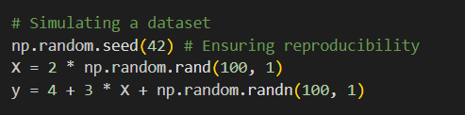

* Utilize numpy for mathematical operations.
* Plotting can be done using matplotlib.

Grading Rubric (Total: 100 Points)

* **Data Understanding and Preprocessing (20 points):** Properly generating, visualizing, and preprocessing the data.
* **Implementation of Linear Regression Equation (20 points):** Correct formulation and implementation of the linear regression equation.
* **Cost Function Calculation (20 points):** Accurate implementation and calculation of the cost function.
* **Gradient Descent Implementation (20 points):** Correct implementation of gradient descent for parameter optimization.
* **Prediction and Model Evaluation (20 points):** Accuracy of predictions on unseen data and evaluation of model performance.